Trigger: Gmail new email

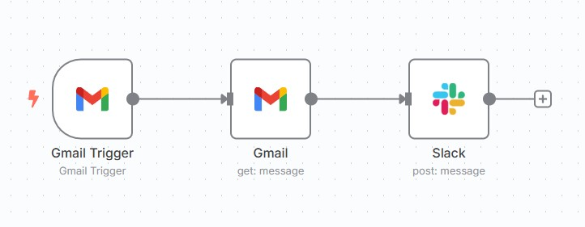Next steps: get details of email and send the message to slack channel

Trigger: Gmail

Next steps: once email is received, gmail node checks if the email is labeled as “Summarize” then AI Agent summarizes the email and sends the summary to slack channel

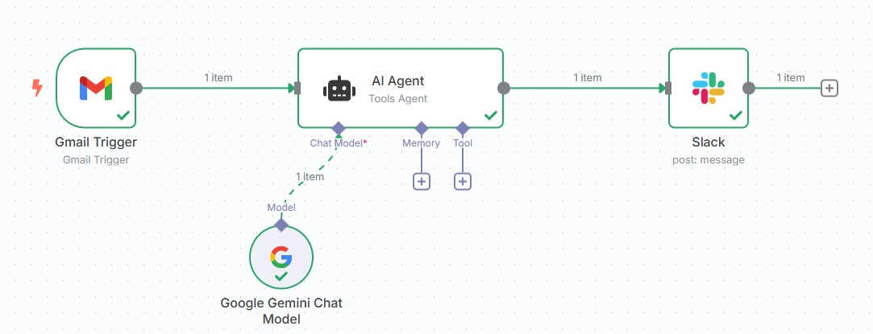

Trigger: Github file upload on a repository

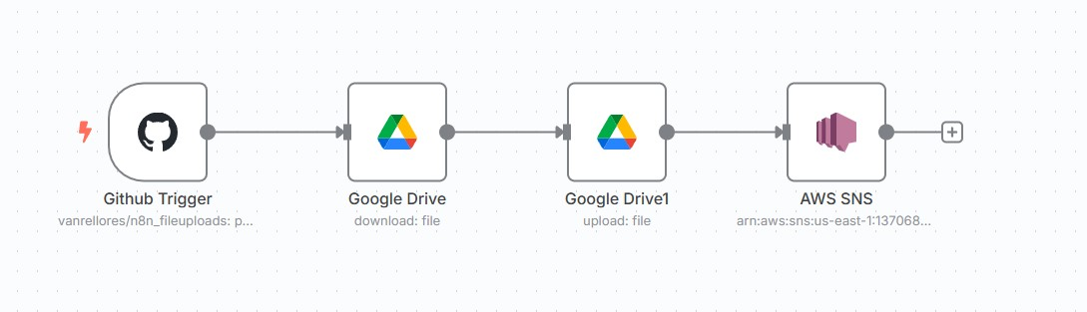Next steps: File is then downloaded from Github by Google Drive node then another Google drive node uploads the file on a folder in Google drive then email notifications are sent to email subscribers on AWS SNS

Trigger: When chat message is received (interactive workflow)

Next steps: The AI agent receives the details of the prompt (emailSubject, emailRecipient and emailBody) with Google Gemini as the LLM, Simple memory and Gmail as Tool then tells you on the Output node the output of the prompt.

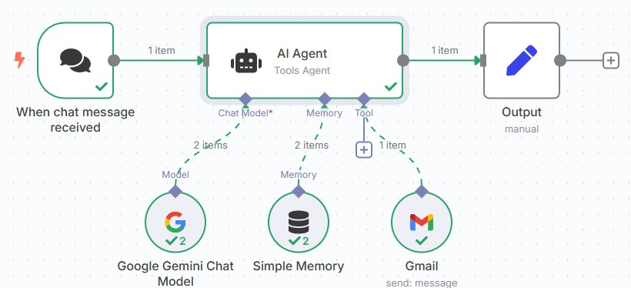

Variant: AI agent has Google sheets as reference for the contacts

